
SRM Institute of Science and Technology
BATCH 1/SET A

College of Engineering and Technology
DEPARTMENT OF ECE
SRM Nagar, Kattankulathur – 603203, Chengalpattu District, Tamilnadu
Academic Year: 2022-23 (EVEN)
Test: CLAT-1 Date: 16/02/2023
Course Code & Title: 18ECE221T Radar and Navigational Aids Duration: 12.30–1.20 PM
Year & Sem: III Year/ VI Sem Max. Marks: 25
Course Articulation Matrix:
S.NO | 18ECE221T- Radar and Navigational Aids | Program Outcomes (PO) |  |  |  |  |  |  |  |  |  |  |  | Program Specific outcomes (PSO)
S.NO | Course Outcomes (CO) | 1 | 2 | 3 | 4 | 5 | 6 | 7 | 8 | 9 | 10 | 11 | 12 | 1 | 2 | 3
1 | Describe the principle operation of radar with the help of range equation and parameters | 3 | 2 | - | - | - | - | - | - | - | - | - | - | - | - | -
2 | Apply Doppler principle to radars and hence comprehend the features of different types of radar | 3 | 2 | - | - | - | - | - | - | - | - | - | - | - | - | -
3 | Analyze the reception of Radar signals under noise and different propagation modes | 2 | - | - | 3 | - | - | - | - | - | - | - | - | - | - | 1
4 | Illustrate the functions of various parts of Radar transmitters and Receivers | 3 | 2 | - | - | - | - | - | - | - | - | - | - | - | - | -
5 | Outline the principle of navigation with aids of various navigation systems | 3 | - | - | 2 | - | - | - | - | - | - | - | - | - | - | 1

Part - A
(5 x 1 = 5 Marks)
Instructions: Answer all
Q. No | Question | Marks | BL | CO | PO
1 | a.8 GHz – 12 GHz | 1 | 1 | 1 | 1
2 | d. 0.8 | 1 | 1 | 1 | 2
3 | a. 934pW | 1 | 1 | 1 | 2
4 | a. Fast scanning | 1 | 1 | 1 | 1
5 | c. E Scope | 1 | 1 | 1 | 1
Part – B
(2 x 4 = 8 Marks)
Instructions: Answer any 2
6 | Four cases of Swerling Target model : (4 Marks)  Case 1: The echo pulses received from a target on any one scan are of constant amplitude throughout the entire scan but independent from scan – scan fluctuation. Also called slow fluctuations.  Case 2: The pdf is same as that of case 1, but the fluctuations are independent from pulse to pulse rather than from scan to scan. Also called fast fluctuations.  Case 3: As in case 1, the radar cross section is assumed to be constant with a scan to scan  Case 4: The fluctuation is pulse to pulse, but with the same pdf as case 3.  The cross section to be substituted in the radar equation for these cases is the average value  Case 1 Pdf:  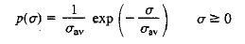  Case 2 Pdf:  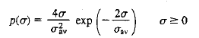 | 4 | 2 | 1 | 1
7 | Draw a block diagram representing a pulse radar system.  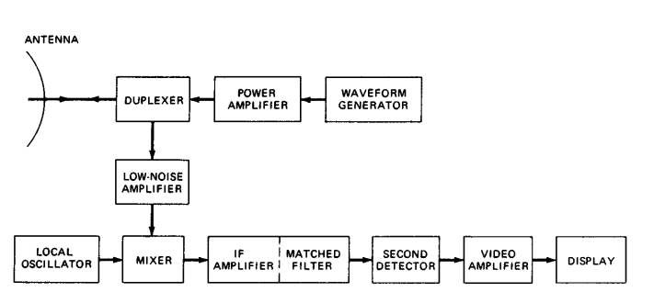 | 4 | 1 | 1 | 1
8 | Ornate the importance of matched filter in a RADAR System.  -Maximization of SNR  -Fixing the Threshold for detection. | 4 | 1 | 1 | 1
Part – C
(1 x 12 = 12 Marks)
Instructions: Answer any one
9 (a) | System Losses:  System losses denoted is inserted in the denominator of the radar equation. It is the reciprocal of efficiency (number less than one).  (i)Microwave plumbing losses  There is always loss in the transmission line that connects the antenna to the transmitter and receiver- loss in the various microwave components, such as the duplexer, receiver protector, rotary joint, directional couplers, transmission line connectors, bends in the transmission lines, and mismatch at the antenna.  • Transmission line Loss  The transmission line generally is used for both transmission and reception the loss to be inserted in the radar equation is twice the one way loss. Flexible waveguides and coaxial lines can have higher losses than conventional waveguides. When practical transmitter and receiver should be placed close to the antenna to keep the transmission loss small.  • Duplexer loss:  The loss due to a gas duplexer that provides the receiver from high power of the transmitter is generally different o transmission and reception.  (ii)Antenna losses:  It should be accounted for in the antenna gain, shaping of the antenna pattern.  • Beam shape loss:  The train of pulses returned from a target by a scanning antenna is modulated in amplitude by the shape of the antenna beam. Only one out of pulses has the maximum antenna gain G.  • Scanning loss:  When the antenna scans rapidly enough, relative to the round trip time of the echo signal, the antenna gain in the direction of the target on transmit might not be the same as that on receive which causes loss called scanning loss.  • RADOME:  Loss introduced by a radome will depend on the type and the radar frequency. Air supported radomes can have lower loss; the loss with dielectric space-frame radomes can be higher.  • Phased Array Losses:  Some phased array radars have additional transmission line losses due to the distribution network that connects the receiver and transmitter to each of the many elements of the array.  (iii) Signal processing losses:  The factors below can introduce significant loss that has to be accounted.  o Non matched filter:  There can be from 0.5 to 1.0 dB of loss due to practical rather than ideal matched filter.  o Constant false alarm rate (CFAR) receiver:  This loss can be more than 2.0 dB depending on the type of CFAR.  o Automatic integrators:  The binary moving window detector, for example, can have a theoretical loss of 1.5 to 2.0dB. Other automatic integrators might have more or less loss.  o Threshold level:  A threshold is established at the output of the radar receiver to achieve some specified probability of false alarm or average alarm time. Depending on how accurately the threshold can be set and maintained, the loss might be only a small fraction of dB.  o Limiting loss:  Some radars might use a limiter in the radar receiver. An example is pulse compression processing to remove amplitude fluctuations in the signal.  o Straddling loss:  A loss called the range straddling loss, occurs when range gates are not centered on the pulse or when, for practical reasons, they are wider than optimum.  o Sampling loss:  The difference between the sampled value and the maximum pulse amplitude represents a sampling loss.  (iv)Losses in Doppler processing Radar:  MTI Doppler processing also introduces loss due to the shape of the Doppler filters if the target velocity does not correspond to the maximum response of the Doppler filter.  (v)Collapsing loss:  If the radar were to integrate additional noise samples along with signal-plus noise pulses, the added noise would result in a degradation called collapsing loss.  (vi)Operator loss:  Most modern high performance radars provide the detection decision automatically without intervention of a human operator.  (vii)Equipment degradation:  It is not uncommon for radars operated under field conditions to have lower performance than when they left the factory. This loss of performance can be recognized and corrected by regularly testing the radar, with built in test equipment that automatically in | 12 | 2 | 1 | 2
9(b) | Frequency f = 1500MHz, Range=741 Km, Radar cross section = 2 Sq. m, A _{e} = 48 Sq.m  - Antenna effective aperture area 48 Sq. m  λ= c/f = 3x 10⁸ /(1500 x 10 ⁶) = 0.2  Gain =( 4*pi*A _{e} )/ λ²  G = (4 x 3.14 x 48)/(0.2)² = 15072  G in dB = 41.78 dB  - Peak Transmission Power:  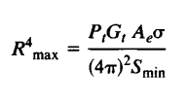  P_{t} = 3.28 KW  - Pulse repetition frequency : R _{max} = 741 Km  R_{un} = c /(2f_{p}) = 202 Hz  Average transmit power  P_{av} = P_{t} 𝜏 f_{p} = 3.28 x 10 ³ x 2 x 10⁻⁶ x 202 = 1.325 W  - Duty cycle  P _{av} /P _{t} = 1.325 /(3.28 x 10³) = 0.4039 ms | 12 | 2 | 1 | 2
Course Outcome (CO) and Bloom’s level (BL) Coverage in Questions
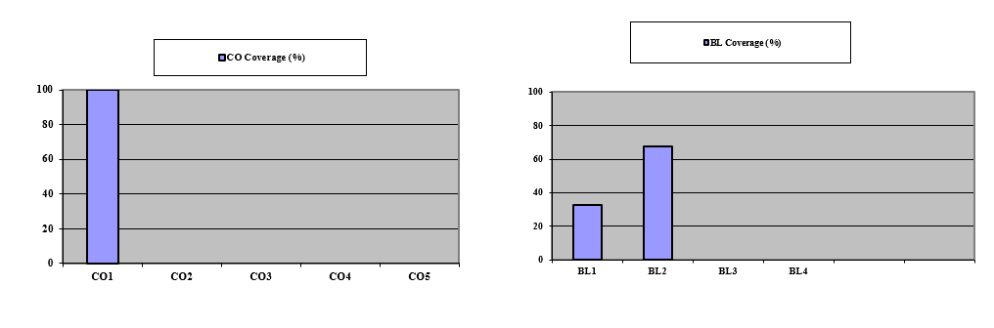
Approved by the Course Coordinator Signature of the Question paper setter

Evaluation Sheet

Name of the Student: Register No.:
Part- A (10x 1= 10 Marks)
Q. No | CO | PO | Maximum Marks | Marks Obtained | Total
1 | 1 | 2 | 1
2 | 1 | 1 | 1
3 | 1 | 1 | 1
4 | 1 | 1 | 1
5 | 1 | 1 | 1
Part - B (2 x 4 = 8 Marks)
6 | 1 | 2 | 8
7 | 1 | 1 | 8
8 | 1 | 1 | 8
Part - C (1 x 12 = 12 Marks)
9a | 1 | 2 | 12
9b | 1 | 2 | 12
Consolidated Marks:

PO | Maximum Marks | Marks Obtained
1
2
Total
CO | Maximum Marks | Marks Obtained
1
Total

Signature of Course Teacher

Signature of the Course Coordinator Signature of the Academic Advisor

SRM Institute of Science and Technology
BATCH 2/SET B

College of Engineering and Technology
DEPARTMENT OF ECE
SRM Nagar, Kattankulathur – 603203, Chengalpattu District, Tamilnadu
Academic Year: 2022-23 (EVEN)
Test: CLAT-1 Date: 16/02/2023
Course Code & Title: 18ECE221T Radar and Navigational Aids Duration: 8.00–8.50 AM
Year & Sem: III Year/ VI Sem Max. Marks: 25
Course Articulation Matrix:
S.NO | 18ECE221T- Radar and Navigational Aids | Program Outcomes (PO) |  |  |  |  |  |  |  |  |  |  |  | Program Specific outcomes (PSO)
S.NO | Course Outcomes (CO) | 1 | 2 | 3 | 4 | 5 | 6 | 7 | 8 | 9 | 10 | 11 | 12 | 1 | 2 | 3
1 | Describe the principle operation of radar with the help of range equation and parameters | 3 | 2 | - | - | - | - | - | - | - | - | - | - | - | - | -
2 | Apply Doppler principle to radars and hence comprehend the features of different types of radar | 3 | 2 | - | - | - | - | - | - | - | - | - | - | - | - | -
3 | Analyze the reception of Radar signals under noise and different propagation modes | 2 | - | - | 3 | - | - | - | - | - | - | - | - | - | - | 1
4 | Illustrate the functions of various parts of Radar transmitters and Receivers | 3 | 2 | - | - | - | - | - | - | - | - | - | - | - | - | -
5 | Outline the principle of navigation with aids of various navigation systems | 3 | - | - | 2 | - | - | - | - | - | - | - | - | - | - | 1

Part - A
(5 x 1 = 5 Marks)
Instructions: Answer all
Q. No | Question | Marks | BL | CO | PO
1 | Choose the appropriate operating frequency of a Radar that operates in Ku band  - 8 GHz – 12 GHz  - 12 GHz – 18 GHz  - 1 GHz – 2 GHz  - 4 GHz – 8 GHz | 1 | 1 | 1 | 1
2 | RADAR has a maximum Range of 500 Km. The Pulse Repetition Frequency to obtain unambiguous reception is  a. 5000 Hz  b. 300 Hz  c. 200 Hz  d. 500 Hz | 1 | 1 | 1 | 2
3 | The following model can be used for detection of complex targets  a. Fresnel  b. Hauffman  c. Swirling  d. Sipman | 1 | 1 | 1 | 2
4 | Select the object that is detected in the optical region  a. Rain Droplets  b. Molecules  c. Aircraft  d. Lead Particles | 1 | 1 | 1 | 1
5 | Identify the odd one out in terms of multipath propagation effect  a. Total internal Reflection  b. Diffraction  c. Reflection  d. Scattering | 1 | 1 | 1 | 1
Part – B
(2 x 4 = 8 Marks)
Instructions: Answer any 2
6 | A RADAR wavelength and dimension of the target are the important parameters to predict simple targets. Draw a region graphical representation for the same. | 4 | 2 | 1 | 1
7 | The most important part of any wireless system is to analyse its surrounding effects (due to the possibilities of multipath propagation mechanism) and the device itself for a proper prediction at the receiver side. Based on the aforementioned statement, elaborate the importance of the threshold detection problems in a RADAR. | 4 | 1 | 1 | 1
8 | Ornate the importance of Duplexer in a RADAR System. | 4 | 1 | 1 | 1
Part – C
(1 x 12 = 12 Marks)
Instructions: Answer any one
9 (a) | I am a wireless system and exploit super heterodyne receiver. I will have to be used by our country’s Army to detect and predict any unwanted object moving towards or away from the borders. As an Army Wing Communication Engineer, predict the range of the objects by deducing the expression for the aforementioned scenario and elaborate the same in terms of pure Transmitting Gain (G) component.  (OR) | 10 | 2 | 1 | 2
9(b) | A ground based air surveillance radar operates at a frequency of 1500 MHz. Its maximum unambiguous range is 200 Km for the detection of a target with a bandwidth of 1 MHz.  Determine the following.  - Pulse Repetition Frequency  - Pulse Repetition Interval  - Range Resolution  - Pulse width | 10 | 2 | 1 | 2
Course Outcome (CO) and Bloom’s level (BL) Coverage in Questions
Approved by the Course Coordinator Signature of the Question paper setter

Evaluation Sheet

Name of the Student: Register No.:
Part- A (10x 1= 10 Marks)
Q. No | CO | PO | Maximum Marks | Marks Obtained | Total
1 | 1 | 2 | 1
2 | 1 | 1 | 1
3 | 1 | 1 | 1
4 | 1 | 1 | 1
5 | 1 | 1 | 1
Part - B (2 x 4 = 8 Marks)
6 | 1 | 2 | 8
7 | 1 | 1 | 8
8 | 1 | 1 | 8
Part - C (1 x 12 = 12 Marks)
9a | 1 | 2 | 12
9b | 1 | 2 | 12
Consolidated Marks:

PO | Maximum Marks | Marks Obtained
1
2
Total
CO | Maximum Marks | Marks Obtained
1
Total

Signature of Course Teacher

Signature of the Course Coordinator Signature of the Academic Advisor

